Access World History Mid-Term Exam

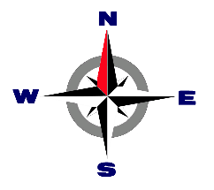
- What is this?

- Map key
- Map
- Compass

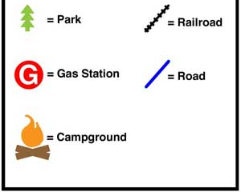
- What is this?

- Map
- Compass
- Map Key

- The map key and compass help people find places on a map.
  - True
  - False

- Choose the best answer:
The study of ______________________ helps us solve problems of today.
  - History
  - Historians
  - Heritage
- Draw a line to match the time measurements:

1 week |  | 10 years
1 decade |  | 100 years
1 century |  | 7 days

- What is the name of the continent we live in?
A. North America
B. United States
C. Australia 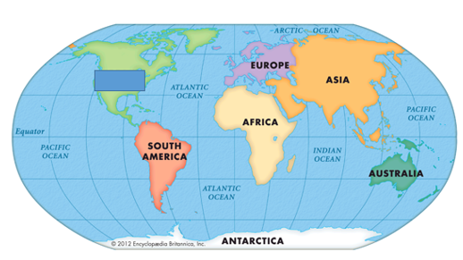

- What are the 7 continents?
  - France, Europe, Antarctica, Florida, Australia, Africa, Outback
  - Europe, Antarctica, Florida, Australia, Africa, South America, North America
  - Europe, Antarctica, North America, South America, Australia, Africa, Asia
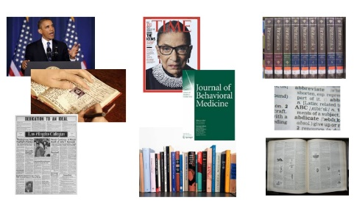

- Historians use sources to learn about history. What are these types of sources called?
  - 1st and 2nd
  - primary and secondary
  - old and new

- Draw a line to match the Religion with the symbol:

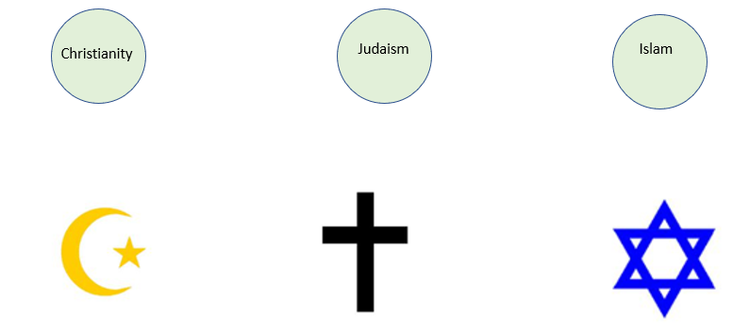

- What is an empire?
- A large group of lands run by an emperor or empress.
- A city with a by a mayor running it
- A county with a president running it

- What were the Roman’s credited with inventing?
  - Fire
  - Aqueducts
  - Automobiles

- What continents did the Empire of Rome cover?
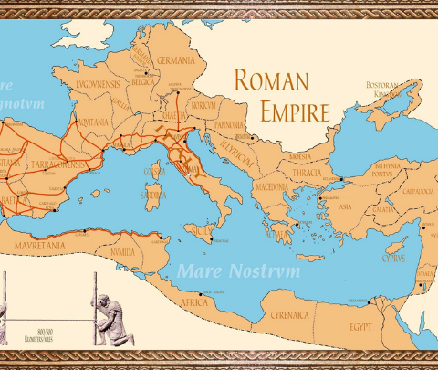

  - Florida, US, China
  - Asia, Europe, South America
  - Asia, Africa, Europe

- What were two achievements that Constantine did?

  - Constantine made Christianity against the law and moved the capitol of Rome to Constantinople.
  - Constantine and Justinian were friends, who went to church together.
  - Constantine said Romans can practice Christianity and moved the capitol of Rome to Constantinople.

- Why did the Roman Empire fall?
  - Barbarian attacks, army and money concerns.
  - Justinian’s new laws.
  - The crusades

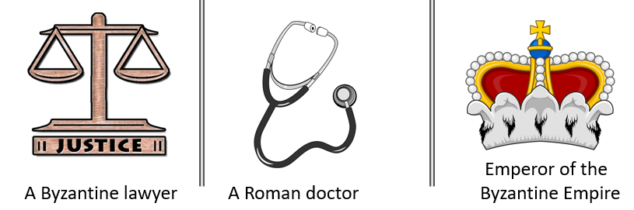
- Who was Justinian?

- A Byzantine lawyer
- A Roman doctor
- Emperor of the Byzantine Empire

- Who was the leader of the Byzantine Empire who created code of law and rebuilt the Hagia Sophia.
  - Justinian
  - Mansa Musa
  - Justin Bieber

- What is a pilgrimage?

  - A holiday
  - A trip
  - A city

- What is the Quran?
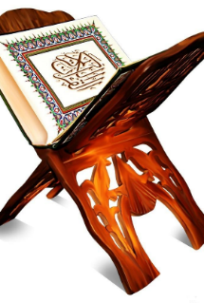
  - An old song
  - A holy book
  - A funny story

- Who is an important person in the history of Islam?
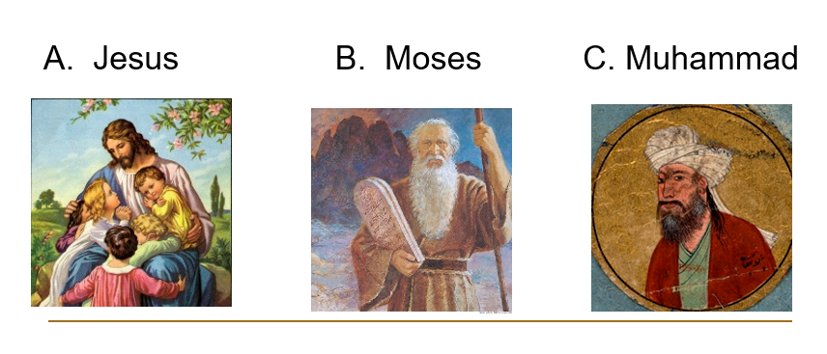

- Sunni and Shia are:

- Two groups of Christians, that did not agree.
- Two groups of Muslims that wanted the same leader after Muhammad died.
- Two groups if Muslims that wanted a different leader after Muhammad died.

- What is a Caliph?
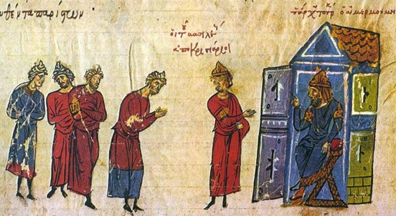

- The leader of the Europeans during the Middle Ages.
- The religious and political leader of the Muslim world.
- The president of Africa and Asia.
- What is the relationship between religion, and the Islamic Expansion?

- As governments expanded, they were able to spread the religion of Islam easier.
- More people became Christian during the Islamic Expansion.
- There is no relationship, Islamic people got more land, but that has nothing to do with religion.

- What are the Crusades?
  - A series of wars between the Muslims and Christians
  - A series of wars between the Mayan and Olmec
  - A war between Ghana and Japan

- During the Crusades what was the holy land the Muslims and Christians were fighting for?
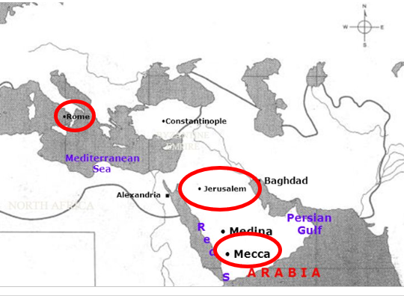

- Rome
- Jerusalem
- Mecca
- Why was the Third Crusade important?
- Saladin gave Richard the Lionhearted the land, and the war was over.
- Saladin and Richard the Lionhearted made a compromise that the Christians can visit Jerusalem.
- Saladin and Richard the Lionhearted fought a big war over Jerusalem.

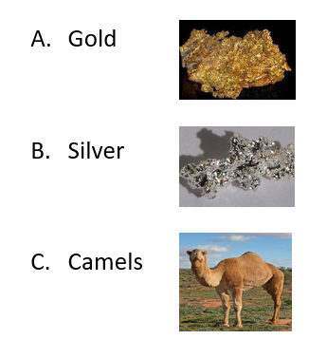
- What resource did Ghana trade?

- Which African Kingdom took over when the Ghana Empire fell?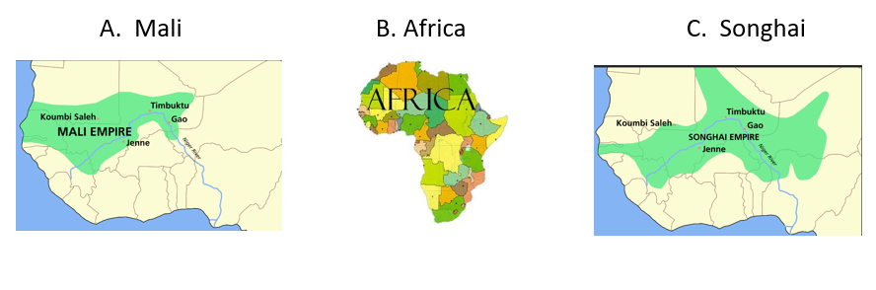
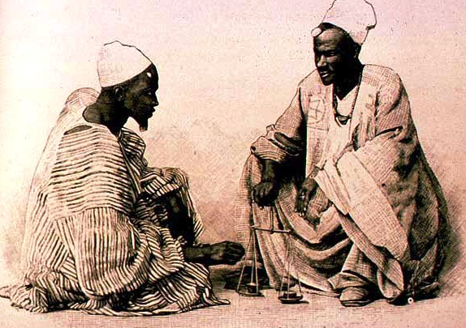
- What are two African Kingdoms from the Middle Ages?

- Mali and Gummi
- Ghana and Mali
- Dinga and Mansa

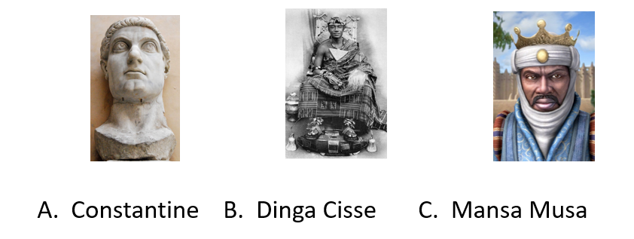
- Who was the leader of the Mali Empire?

- Which of these facts is NOT true about the Songhai Empire?

- Dinga Cisse was the emperor of Songhai.
- In the Empire of Songhai, they mostly traded iron.
- The Songhai empire was taken over by the Moroccan Empire.

- What is something that the Empire of Ghana, Mali, and Songhai share in common?
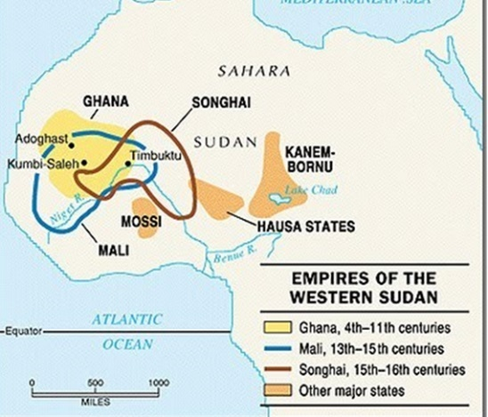

- Mansa Musa ruled them.
- They all were ancient empires in Western Africa.
- They all were ancient empires in Eastern Africa.

- Draw a line to match the vocabulary with the definition.
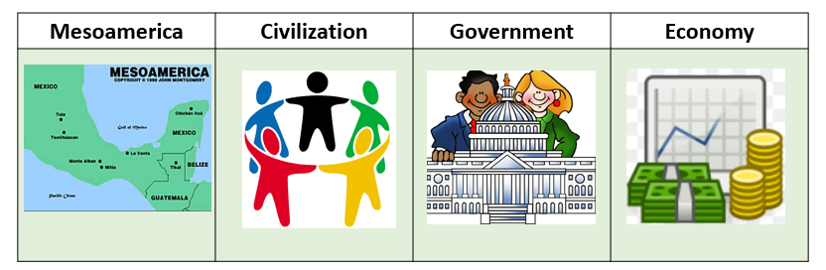

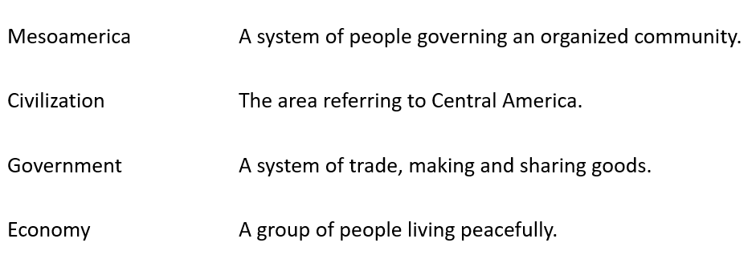
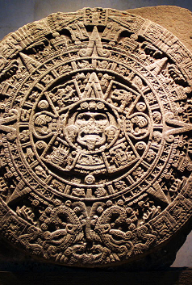
- Which civilization created the first calendar?
    - Maya
    - Chavin
    - Inca

31. Where is Mesoamerica?
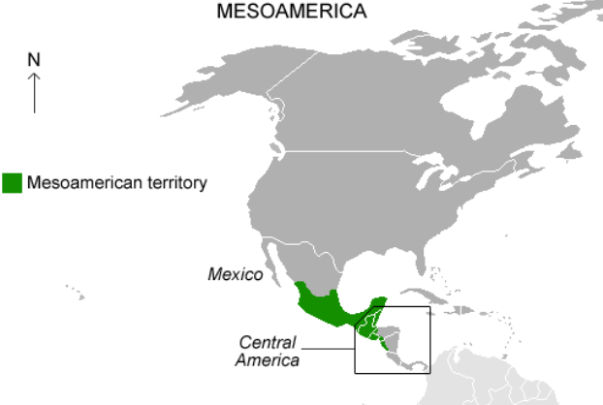

- In America and Mexico
- In Europe and Asia
- In Mexico and Central America
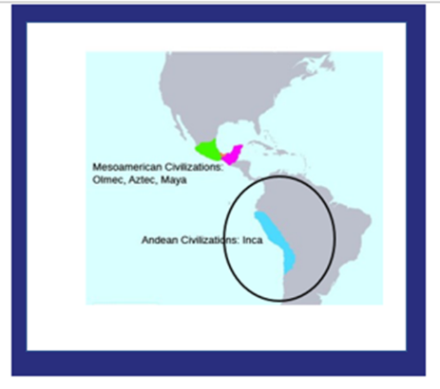
31. Who influenced the Incas?
- Mayans
- Chavins
- Olmecs

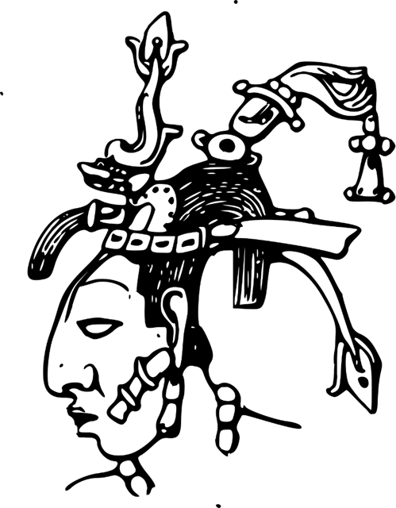
32. Draw a line to match the leader to his empire.

Pacal the Great Inca Empire
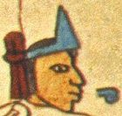

Moctezuma I Mayan Empire
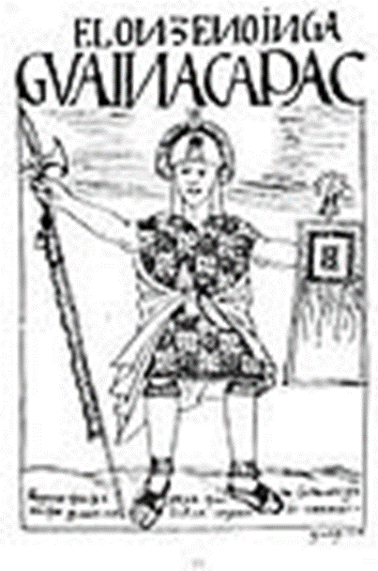

Huayna Capac Aztec Empire

- What is something these men all shared in common?
The Byzantine empire The Mayan Empire The Mali Empire
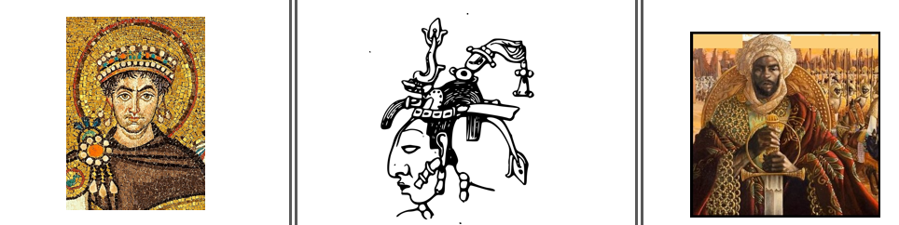
Justinian Pacal the Great Mansa Musa
- They were all from Europe.
- They were all important leaders in history.
- They all died the same year.

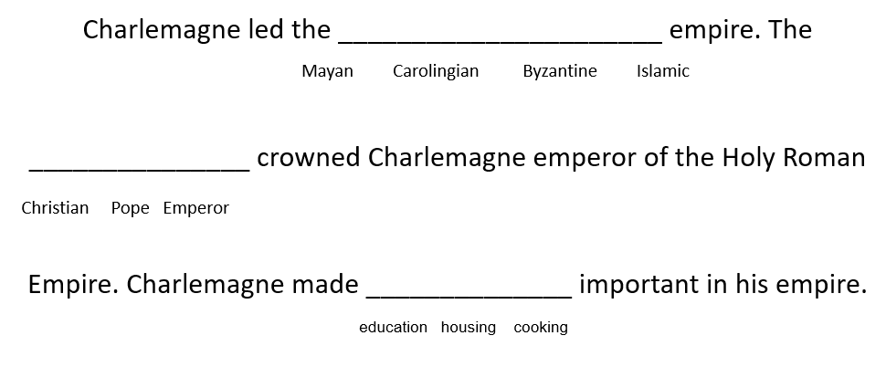
- Circle the best answer

- What is an achievement of Charlemagne?

- He improved and placed importance on shopping.
- He improved and placed importance on education.
- He improved and placed importance on war.

- Draw a line to match the word with the definition:
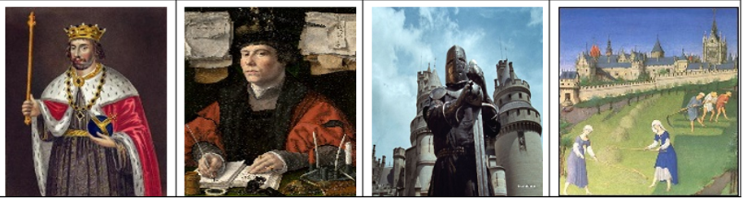
KING NOBLES KNIGHTS SERFS

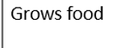
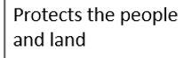
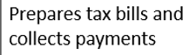
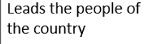

- Which order from top to bottom is correct?
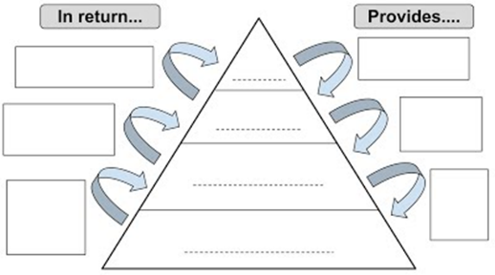

  - King, Noble, Knight, Peasant
  - King, Peasant, Teacher, Student
  - King, Pope, Slave, Knight

- The economic system during the middle ages traded services for land.
  - Feudalism
  - Economic
  - Commission

- Place these events on a timeline.
Middle Ages
Renaissance
Fall of Rome

- Communities in a feudal system were divided into manors which were designed to be self-sufficient.
Using the map, list 3 things included in all manors which helped them be self-sufficient.
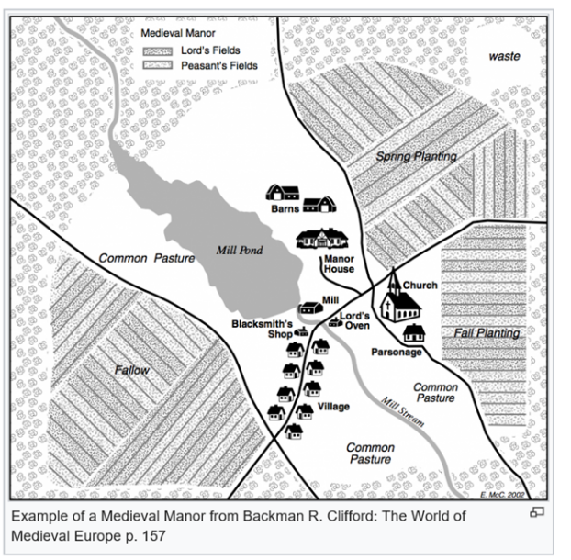

1.
2.
3.

- What are ways that monasteries helped people during the middle ages?
  - Gave people shelter
  - Helped the sick
  - Fed people
  - All of the above

- Draw a line and match the vocabulary to the definition

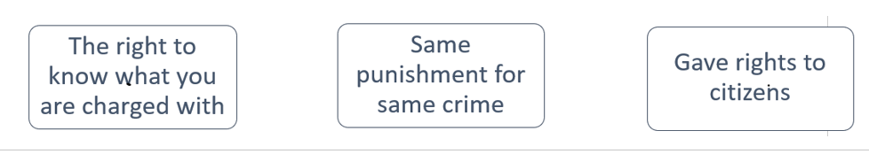

- How was the Black Plague used as a weapon?

  - People poisoned drinks with it.
  - People would send the dead bodies, and the sick to the villages they wanted to attack.
  - People would cough on their enemies in hopes they would get it.

- What was the Great Famine in 1315?

  - It was a time where there was a lot of rain, and mosquitos killed people.
  - It was a popular dance that families did in 1305.
  - It was a time where the weather was bad for growing crops, and many people starved to death.

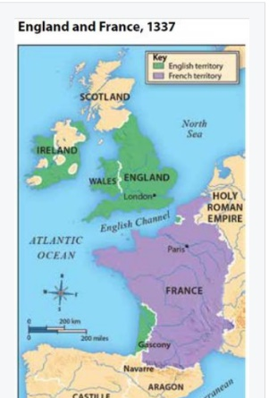
- Which countries were fighting in the Hundred Years War?

  - France and Spain
  - England and France
  - England and Africa

- What was a shogun?

  - A warrior, and character in famous movies.
  - An emperor, and ruler of Japan.
  - A military leader, and ruler of Japan.

- Who had the most power in Shogunate Japan during the middle ages?
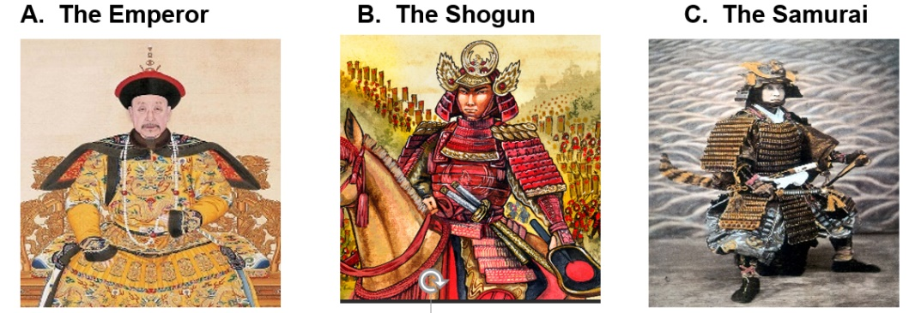

- Who did Japan trade with in the middle ages?
  - China
  - Africa
  - Rome

- Looking at the European Feudal System and the Japanese Feudal System complete the chart below.
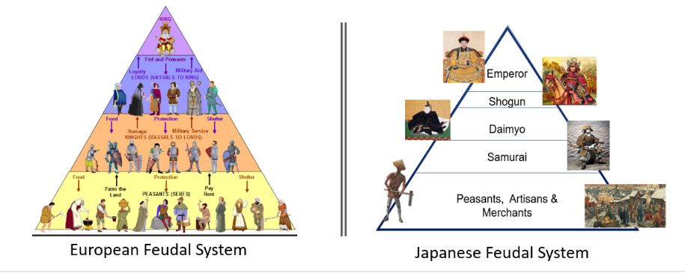

List 2 similarities | List 2 differences

